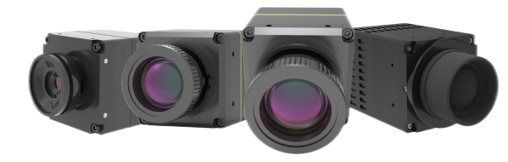

V1.0
Technical Manual
BW-TM16P series
Network thermal imaging core

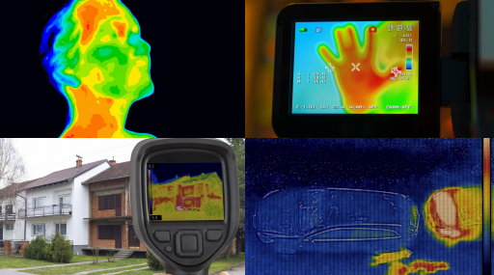
Introduction
Feature
BW-TM series non-cold standard motion is a self-developed image processing technology and intelligent algorithm, using infrared lenses with different focal lengths, through professional signal processing circuits and image processing platforms, the target infrared radiation is completely restored to temperature data, and presented as a clear thermal image. We provide customers with customized products and services, as well as application solutions in the fields of power equipment inspection, scientific research, safe production, storage of hazardous materials, hotels, shopping malls and so on.

● Compatible and easy to merge
● Support secondary development for different focal lengths
● Compact size and easy to integrate
● Meet the specific requirements of industrial temperature measurement
● High sensitivity, NETDS50mK
● Accurate temperature measurement, support multi-gear temperature measurement

Characteristic

Performance Indicators

Network mobile
Product Model | BW-TM16P
Detector Type | Uncooled Vanadium Oxide Infrared Focal Plane Detectors
Resolution | 640×512
Pixel Size | 12μm
Response Band | 8 ~14μm
Detector Noise Equivalent Temperature Difference | ≦40mK@25℃
Images and videos
Contrast and brightness | Automatic manual
Palette | white-hot, black-hot, iron-red, red-hot, rainbow and other
Image processing | unevenness correction
Image processing | Intelligent gain control
Image processing | Detailed hybrid enhancement
Image processing | 3D noise reduction
Video Type | H264, Mainstream: 720 x 576 @ 25fps
Temperature Measurement Performance
Temperature measurement range | -20℃ ~ +150℃ , 0℃ ~ +550℃
Temperature measurement accuracy | ±2°C or ±2% (from 20°C to 60°C)
Temperature measurement anal | Point, Line and Area Analysis
Integration Protocol
Protocol type | SDK（ windows、 Linux） 、 http、onvif
Power supply
Typical Power Supply | DC 12v
Typical Power  Consumption@25 °C | 1.6W
Connector
Video Output | Article 45
Serial Communication Interface | RS485
Alarm Inputs and Outputs | 1 minute 1 outlet
Physical characteristics
Dimensions (without lens) | 35mm*35mm*35.5mm
Weight (without lens) | 156.5g
Operating temperature | -30℃ ~ +60℃（-20°C ~60°C ensures temperature measurement accuracy）
Storage temperature and humidity | -45℃ ~ +75℃ ,RH≤95%

Wuxi Bewis Sensing Technology LLC
Add： Building 30, NO. 58, Xi uxi Road, Binh u District,
Wuxi City, Jiangsu Province, China
Tel： +89 18921292620
Mail ：sales@bwsensing.com
Web：www.bwsensing.com

Network thermal imaging core

BW-TM16P series

