
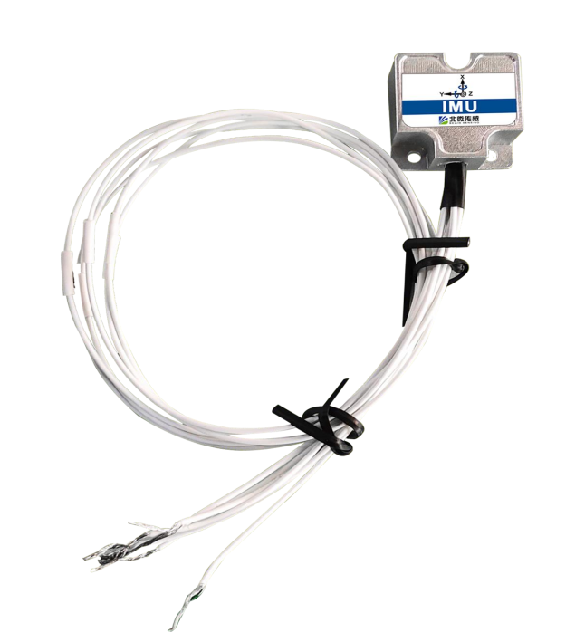

IMU100S

Large range small volume inertial measurement units
Technical Manual
V1.0

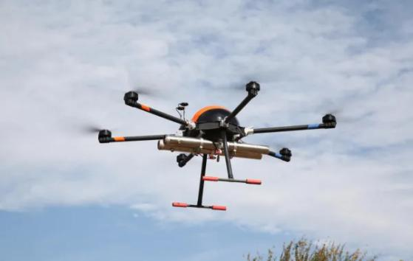




Introduction

The IMU100S is a customised, highly accurate inertial measurement unit that measures angular velocity and acceleration parameters of moving carriers. The raw data is estimated by 6-state Kalman filtering with appropriate gain, making it suitable for inertial measurements in motion or vibration.
The IMU100S uses highly reliable MEMS accelerometers and gyroscopes with algorithms to ensure measurement accuracy, while the hermetically sealed design and rigorous production process ensure that the product can still accurately measure angular velocity, acceleration and other motion parameters of the carrier in harsh environments. The IMU100S is equipped with a digital interface, which makes it very easy to be integrated into the user's system.
Feature

- Dynamic compensation, quadrature compensation
- Sampling frequency up to 200Hz
- Baud rate 115200
Application

- Unmanned ships and underwater robot
- Construction machinery
- Stable platform
- AGV unmanned vehicle
- RS422 output
- Wide temperature range：-40 ℃~+85℃， Temperature compensation
- Small size：22.4×22.4×10mm

- Heavy truck
- Unmanned drive
- Robots
- Unmanned aircraft

Product Feature


Electrical index

Power voltage | 5V DC
Working current | 10mA
Operating temperature | -40~85℃
Storage temperature | -55~100℃

Performance index

Gyro | Range |  | ±500°/sec
Gyro | Full Temperature Zero Bias |  | ≤ 150 °/h
Gyro | Zero Bias Stability (1σ) |  | ≤12 °/h
Gyro | Zero Bias Repeatability (1σ) |  | ≤12 °/h
Accelerometer | Range: X,Y,Z |  | ±10 g
Accelerometer | Zero bias at full temperature |  | ≤5mg
Accelerometer | Zero Bias Stability (1σ) |  | ≤0.3mg
Accelerometer | Zero bias repeatability (1σ) |  | ≤0.3mg
Accelerometer | Supply Voltage |  | 5V
Systems | Operating Temperature Range |  | -40~85℃
Systems | Shock Resistance |  | ≥2000g
Systems | Vibration |  | ≥20grms
Systems | Dimensions |  | 22.4×22.4×10mm
Systems | Weight |  | ≤30g

Mechanical index

Connector | Bare wire (wire length 30m)
Protection level | IP65
Shell material | Magnesium aluminium alloy anodised
Installation | Three M2.5 screws

Package product size
Product size：L22.4*W22.4*H10(mm)

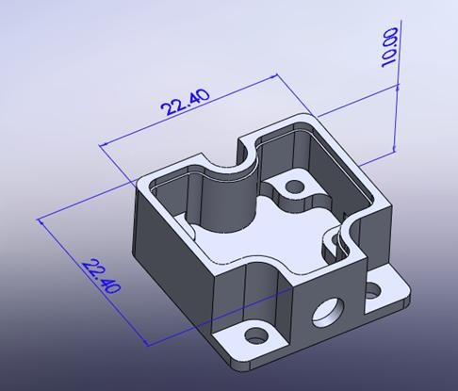
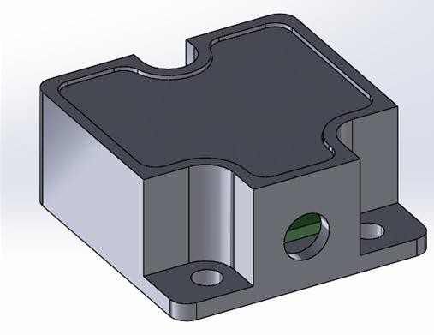

Length and width may have ± 1mm error, please prevail in kind

Electrical connection

Wiring Definitions
Output Connector Wiring Definitions

define | Description
VCC（+5V） | Power Positive
GND | Power Ground
RX+ | RS422 Receive Positive
RX- | RS422 receive negative
TX- | RS422 transmit negative
TX+ | RS422 Transmit Positive

Order information

Product model Communication mode Package situation
IMU100S |  | RS422 |  | IP65
Executive standard

● National Standard (Draft) for Static Calibration Specification for Biaxial Inclination Sensors
● GB/T 191 SJ 20873-2003 General Specification for Tiltmeters and Levelling Devices

IMU100S series
Large range small volume inertial measurement units

Wuxi Bewis Sensing Technology LLC

Add：Building 30, No.58 Xiuxi Road, Binhu District, Wuxi City, Jiangsu Province, China
Tel：+86 18921292620
Email：sales@bwsensing.com Web：www.bwsensing.com

