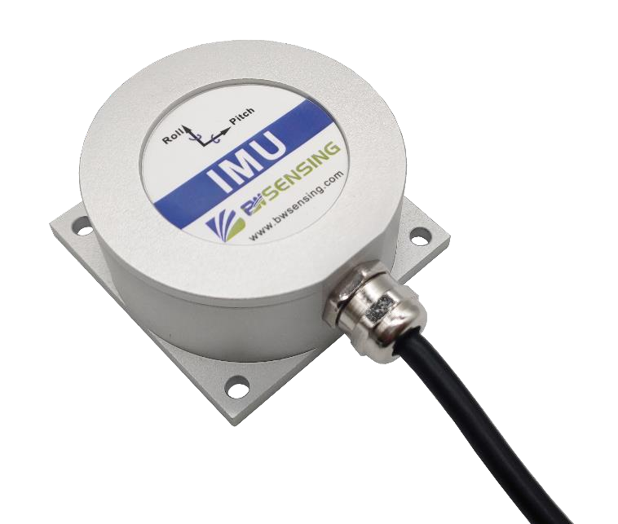



# BW-IMU400C Series

## High-performance

**Inertial Measurement Unit**

**Technical Manual**

V3.0





**Introduction**

BW-IMU400C is a high-precision inertial measurement unit that can measure the angular velocity and acceleration of a moving carrier. The data deviation is estimated by the 6-state Kalman filter with appropriate gain, which is suitable for inertial attitude measurement in motion or vibration state.

BW-IMU400C uses highly reliable MEMS accelerometers and gyroscopes, and it uses algorithms to ensure measurement accuracy. At the same time, the sealing design and strict production process ensure that the product can accurately measure movement parameters such as the angular velocity, acceleration and attitude of the carrier in harsh environments. Through various compensations such as nonlinear compensation, quadrature compensation, temperature compensation and drift compensation, the error source of BW-IMU400C can be greatly eliminated and the product accuracy level can be improved. It has a digital interface, which can be easily integrated into the user's system.

**Feature**

* Dynamic compensation, quadrature compensation
* Sampling frequency up to 500Hz



**Application**

* robots

● Unmanned ships and u

nderwater

* Construction machinery
* Stable platform
* AGV unmanned guided vehicle
* RS232 /485/TTL Output optional
* Wide temperature range：-40 ℃~+85℃， Temperature compensation
* Small size：L60×W59×H29mm
  + Heavy duty truck
  + Unmanned drive
  + Robots
  + Unmanned aircrafts



**Product Feature**



**Electrical index**

|  |  |
| --- | --- |
| Power supply | 9-36V DC |
| Working current | 30mA （40mA max） |
| Operating temperature | -40~85℃ |
| Storage temperature | -55~100℃ |



**Performance index**

|  |  |  |  |
| --- | --- | --- | --- |
| Gyro | Resolution |  | 0.01°/sec |
| Range |  | ± 400°/sec |
| Bias stability at room  temperature |  | ＜ 0.5 °/h（ 100s,1σ）  ＜ 10 °/h（ 10s,1σ） |
| Bias stability at full  temperature |  | ＜ 20 °/h（ 10s,1σ) |
| Angle random walk  coefficient |  | ＜ 0.1 °/√h |
| Bias repeatability |  | ＜ 50 °/h（1σ） |
| Scale factor non-linearity |  | ≤ 100ppm（ 1σ） |
| Scale factor repeatability |  | ≤ 100ppm（ 1σ） |
| Bandwidth |  | 100Hz |
| Accelerometer | Range: X, Y, Z |  | ± 3.6 g |
| Resolution |  | 0.01 mg |
| Bias stability |  | 0.001mg（ 25℃， 100s， 1σ）  0.01mg（ 25℃， 10s， 1σ） |

#### Resolution: The smallest change value of the measured value that the sensor can detect and distinguish within the measurement range.

**Accuracy: The root mean square error of the actual angle and the sensor measuring angle for multiple (≥16 times) measurements.**



**Mechanical Index**

|  |  |
| --- | --- |
| Connector | Metal joint（Cable 1.5m) |
| Protection level | IP67 |
| Shell material | Magnesium aluminum alloy anodizing |
| Installation | Four M4 screws |

**Package product size**



Product size：L60*W59*H29（mm）

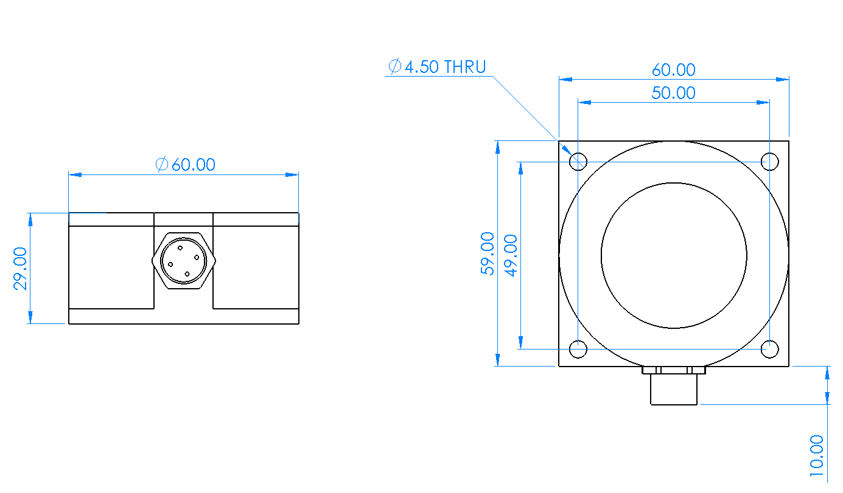

**PCB size**



Product size：L44*W35*H11（mm） The length and width may have an error of

±1mm, please refer to the actual product

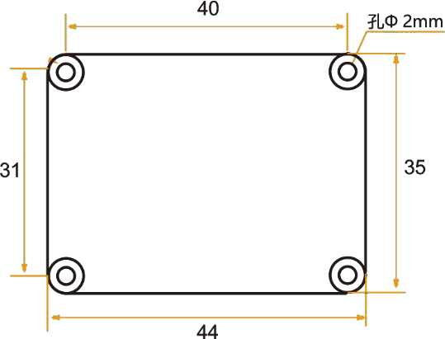



**Installation**

The correct installation method can avoid measurement errors. When installing the sensor, please do the following:

First of all, make sure that the sensor mounting surface is completely close to the measured surface, and the measured surface should be as level as possible, and there should be no included angles as shown in Figure A and Figure C. The correct installation method is shown in Figure B and Figure D.



A

B

uneven surface generates the angle

the measured surface the measured surface





uneven surface generates the angle

the measured surface the measured surface



C



D

Secondly, the bottom line of the sensor and the axis of the measured object cannot have an angle as shown in Figure E. When installing, keep the bottom line of the sensor parallel or orthogonal to the axis of rotation of the measured object. This product can be installed horizontally or vertically (vertical installation needs to be customized), and the correct installation method is shown in Figure F.

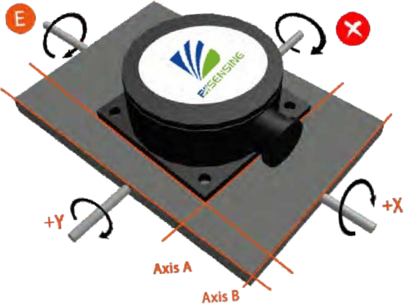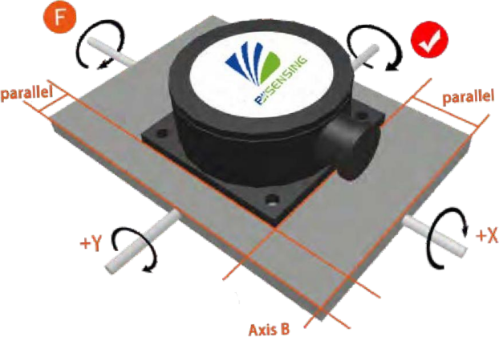

Finally, the mounting surface of the sensor and the surface to be measured must be tightly fixed, smooth in contact, and stable in rotation, and measurement errors due to acceleration and vibration must be avoided.

**Electrical Connection**

Wiring Definition

|  |  |  |  |  |  |  |  |  |  |  |  |  |  |  |  |  |  |  |  |
| --- | --- | --- | --- | --- | --- | --- | --- | --- | --- | --- | --- | --- | --- | --- | --- | --- | --- | --- | --- |
| Wiring color function |  | RED |  |  |  | BLUE |  |  |  | BLACK |  |  |  | GREEN |  |  |  | YELLOW |  |
| 1 | | |  | 2 | | |  | 3 | | |  | 4 | | |  | 5 | | |
| VCC DC 9-36V | | |  | NC | | |  | GND | | |  | Receive RXD B、D- | | |  | Send TXD A、D+ | | |

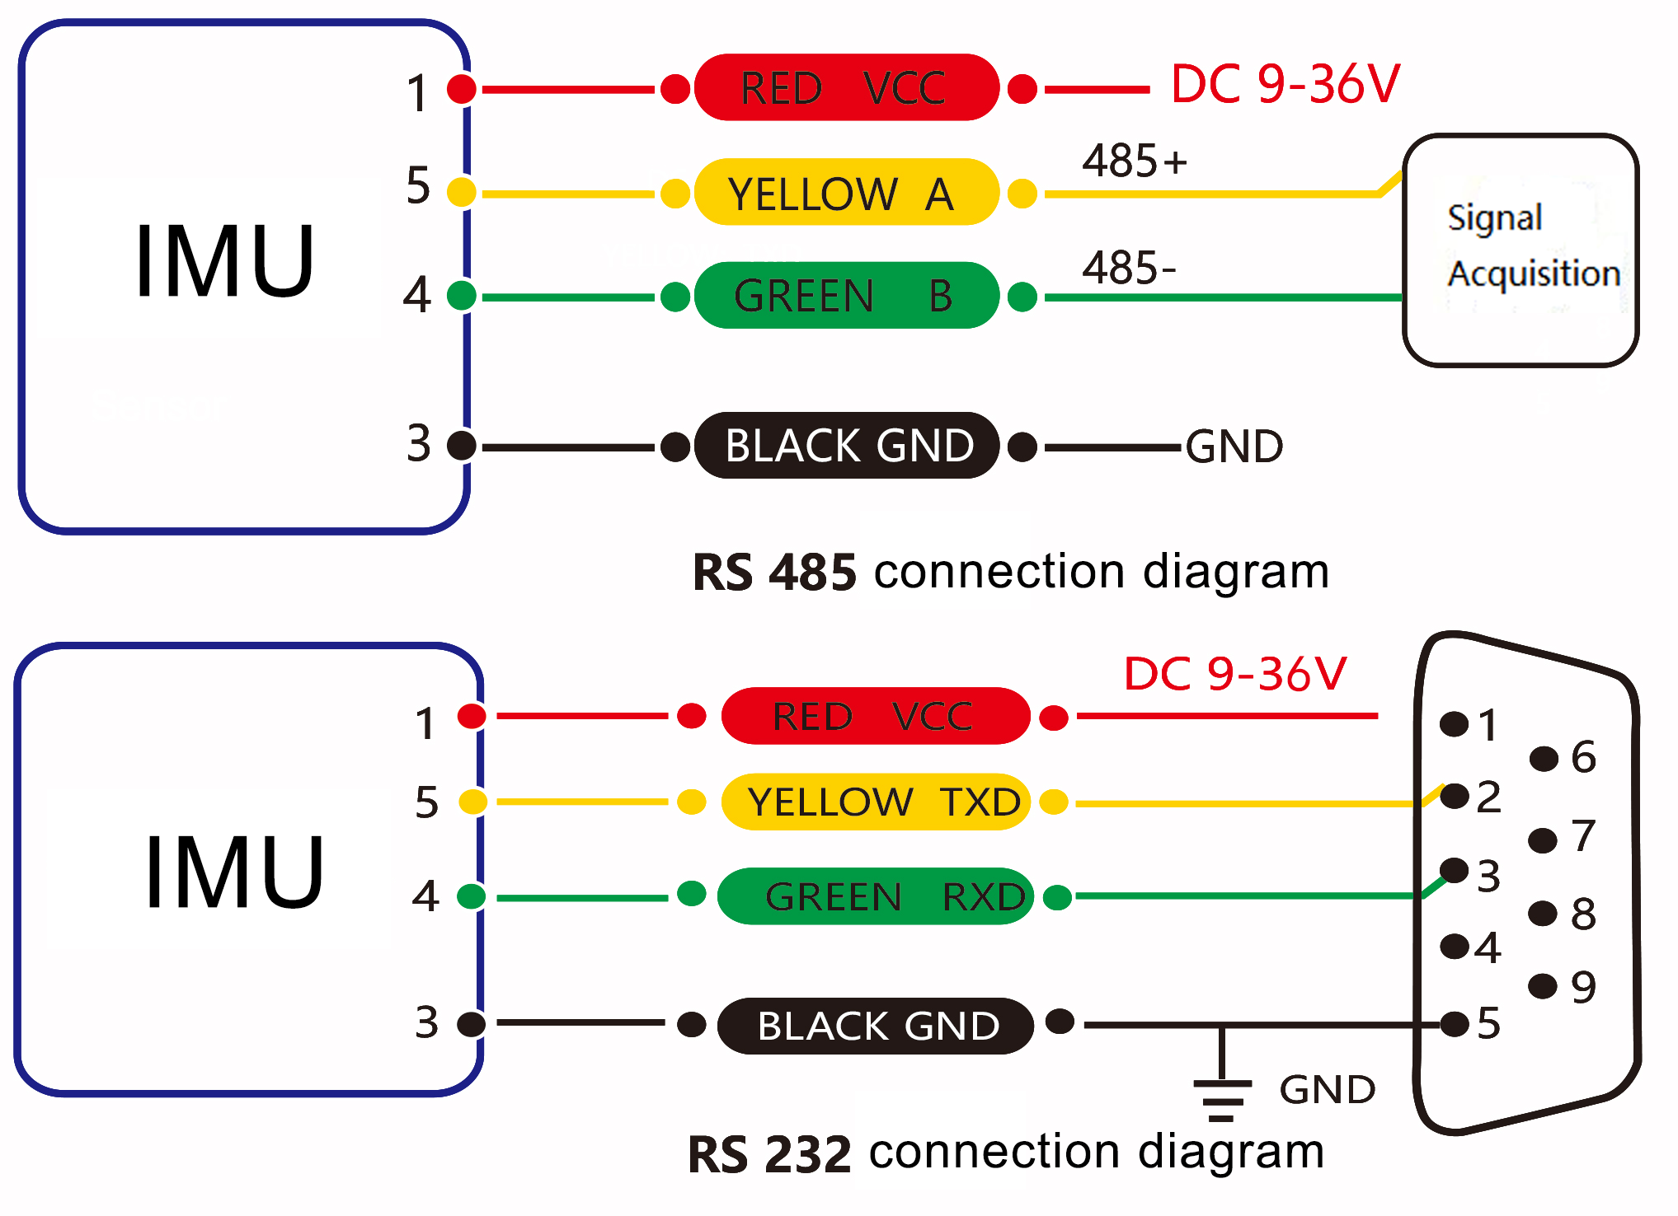

Axial Definition

Three-axis attitude, gyroscope, acceleration data axis

Both obey the right-hand rule.

**Debugging software**

You can download the serial debugging assistant directly on the official website (Technical service -> download area), or you can use the more convenient and intuitive host computer software.

BW-IMU400C supporting serial port debugging software can connect the inclination sensor on the computer to display the angle. The software debugging interface is shown in the figure below. Using the tilt angle to debug the host computer, you can easily display the current X and Y directions, and you can also modify and set other parameters.

**Steps for use：**

① Connect the serial port hardware of the inclinometer correctly, and connect the power supply.

② Select correct device model. (Select azimuth series.)

③ Select computer serial port and baud rate and click connect serial port.

④ Click start button and the current inclination angle of the incliner in X and Y directions will be displayed on the screen.

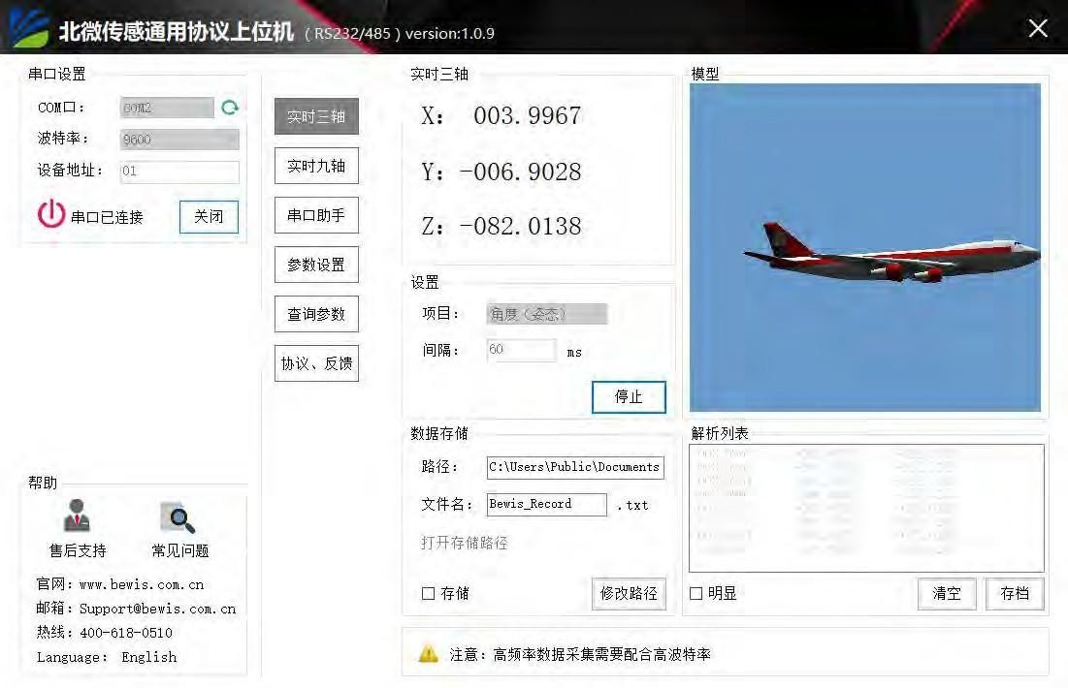

**Order information**

#### Product model Communication mode Package situation

|  |  |  |  |  |
| --- | --- | --- | --- | --- |
| BW-IMU400C-485 |  | RS485 |  | IP67 Package /Metal joint |
| BW-IMU400C -232 |  | RS232 |  | IP67 Package /Metal joint |
| BW-IMU400C -TTL |  | TTL |  | IP67 Package /Metal joint |

**Executive standard**

* + - National Standard for Static Calibration of Biaxial Inclination Sensors (Draft)
    - GB/T 191 SJ 20873-2003 General Specification for Tiltmeters and Levelling Devices



# BW-IMU400C Series

## High-precision Inertial

**Measurement Unit**

**Wuxi Bewis Sensing Technology LLC**

### Add： Building 30, No.58 Xiuxi Road, Binhu District, Wuxi City, Jiangsu Province, China

Tel：+86 18921292620

[Email：sales@bwsensing.com](mailto:sales@bwsensing.com) Web：[www.bwsensing.com](http://www.bwsensing.com/)