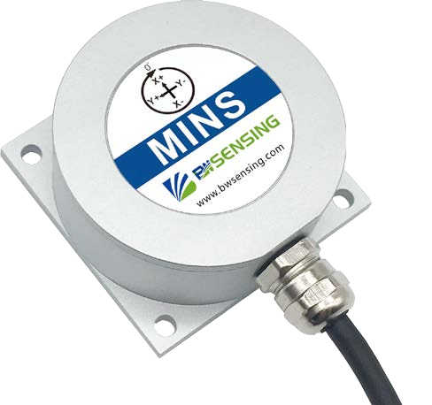



# BW-MINS300 Series

**Cost-effective micro inertial guidance system**

**Technical Manual**

V3.0



**Introduction**

BW-MINS300 is a cost-effective micromechanical electromechanical inertial navigation system developed and produced by BWSENSING. Without relying on external signal input, it can automatically solve the azimuth, roll angle, pitch angle, angular velocity, acceleration, Euler angle and quadrature information of the measured carrier through acceleration and angular velocity information, which is suitable for inertial attitude measurements under various states of motion, vibration or static.

BW-MINS300 adopts highly reliable MEMS accelerometer and gyroscope, the deviation of attitude information data is estimated by 6-state Kalman filter with appropriate gain, and the measurement accuracy is guaranteed by the algorithm, and the attitude and motion parameters are compensated by various compensation such as nonlinear compensation, quadrature compensation, temperature compensation, and drift compensation, which can greatly eliminate the error and improve the product accuracy level. This product is equipped with digital interface, which can be very conveniently integrated into the system.

**Feature**

* Dynamic accuracy：0.3°
* Static accuracy：0.01°
* Wide voltage power supply：9-36V DC
* Special offset tracking algorithm eliminates

drift

**Application**

* Unmanned boats and underwater vehicles
* Robots
* Stable platform
* Large ship
* RS232/RS485/TTL Interface output
* Wide temperature range：-40℃~+85℃，

Temperature compensation

* High-performance Kalman filter algorithm
* Small dimension：L60*W59 * H29 (mm)
* AGV
* Autonomous and unmanned driving
* Special vehicles
* Unmanned aerial vehicle

**Performance Index**

### Electrical Index

|  |  |
| --- | --- |
| Power supply | 9-36V DC |
| Working current | 30mA（40mA max.） |
| Operating temperature | -40~85℃ |
| Storage temperature | -55~100℃ |

**Performance Index**



|  |  |  |
| --- | --- | --- |
| Attitude parameter | Dynamic accuracy | 0.3° |
| Static accuracy | 0.01° |
| Measurement range | Pitch ± 90º, Roll ± 180º |
| Heading Holding Accuracy | 0.1°/60s |
| Gyro | Resolution | 0.01°/sec |
| Bias stability at full temperature | 15°/h（10s,1σ) |
| ARW | ＜0.1 °/√h |
| Bias repeatability | ＜50 °/h（1σ） |
| Scale factor nonlinearity | ≤100ppm（1σ） |
| Scale factor repeatability | ≤100ppm（1σ） |
| Accelerometer | Range：X, Y, Z | ±1.8 g |
| Bias stability | 0.001mg（25℃，100s，1σ）  0.01mg（25℃，10s，1σ） |
| Interface feature | Communication mode | RS232/RS485/TLL |
| Maximum output Frequency | 500Hz |
| MTBF | ≥90000 h/times | |
| EMC | According to GB17626 | |
| Insulation resistance | ≥100MΩ | |
| Impact resistance | 2000g, 0.5ms, 3times/axis | |
| Weight (with cable) | 280g | |

**Mechanical properties**



|  |  |
| --- | --- |
| Connector | Metal joint (cable 1.5m) |
| Protection Level | IP67 |
| Shell material | Magnesium aluminum alloy oxidation |
| Installation | Four M4 screws |

**Package product size**



Product Size：L60 * W59 * H29（mm）

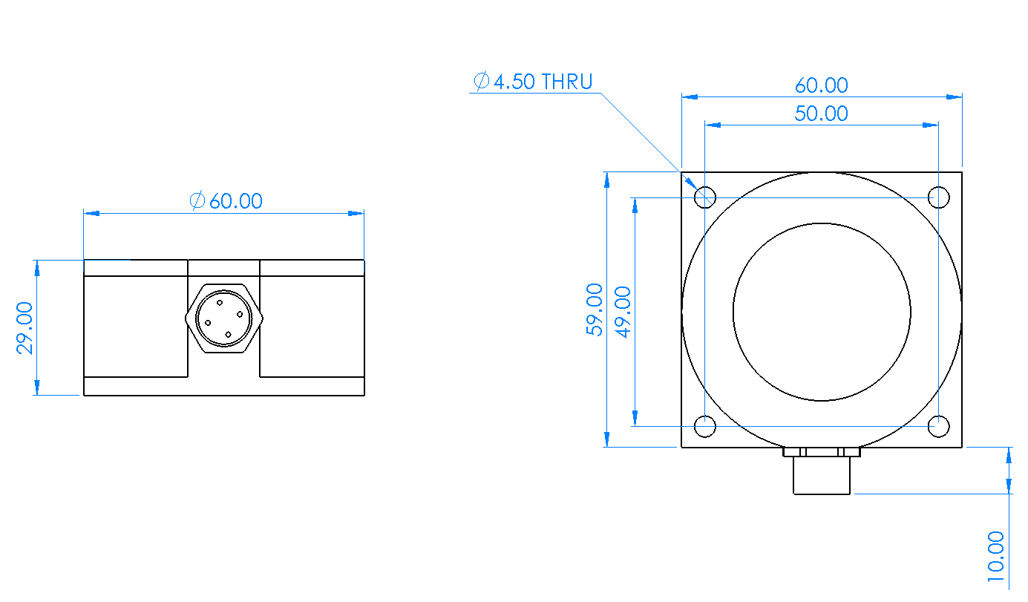

### Bare board product size



Product size：L44*W35*H11（mm） The length and width may have an error of

±1mm, please refer to the actual product

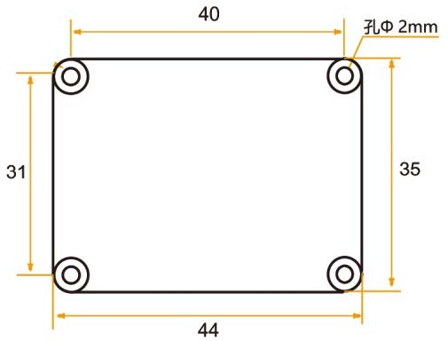

**Installation**

The correct installation method can avoid measurement errors. When installing the sensor, please do the following:

First of all, make sure that the sensor mounting surface is completely close to the measured surface, and the measured surface should be as level as possible. There should be no included angles as shown in Figure A and Figure C. The correct installation method is shown in Figure B and Figure D.



A

B

uneven surface generates the angle

the measured surface the measured surface





uneven surface generates the angle

the measured surface the measured surface



C



D

Secondly, the bottom line of the sensor and the axis of the measured object cannot have an angle as shown in Figure E, and the bottom line of the sensor should be kept parallel or orthogonal to the axis of rotation of the measured object during installation. This product can be installed horizontally or vertically (vertical installation needs to be customized), and the correct installation method is shown in Figure F.

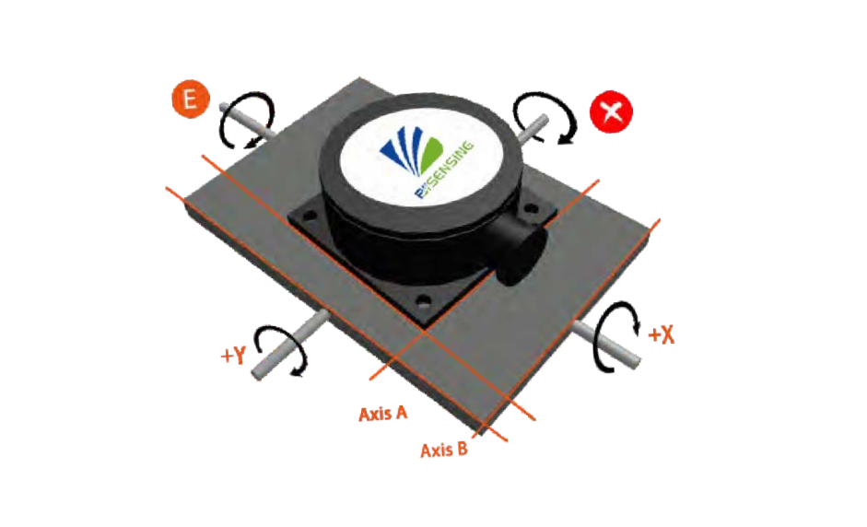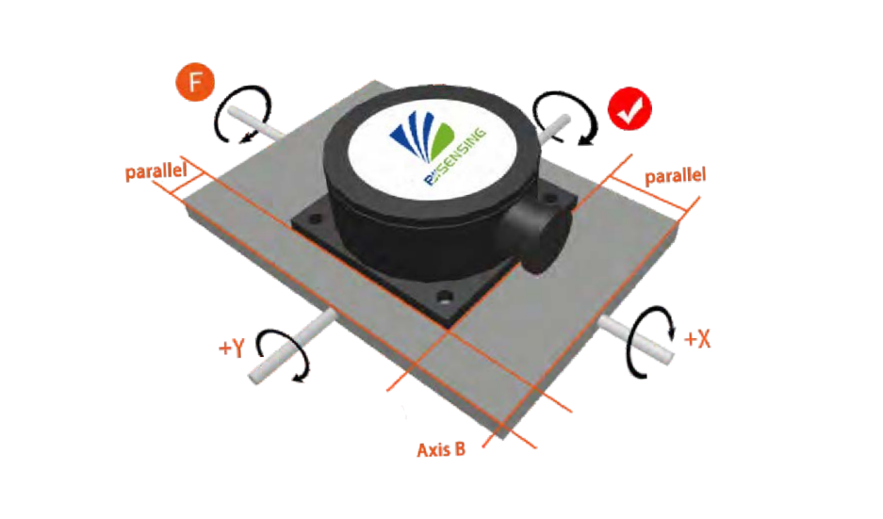

Finally, the mounting surface of the sensor and the surface to be measured must be tightly fixed, smooth in contact, and stable in rotation, and measurement errors due to acceleration and vibration must be avoided.

**Electrical Interface**

Wiring definition

|  |  |  |  |  |  |  |  |  |  |  |  |  |  |  |  |  |  |  |  |
| --- | --- | --- | --- | --- | --- | --- | --- | --- | --- | --- | --- | --- | --- | --- | --- | --- | --- | --- | --- |
| Wire color function |  | RED |  |  |  | BLUE |  |  |  | BLACK |  |  |  | GREEN |  |  |  | YELLOW |  |
| 1 | | |  | 2 | | |  | 3 | | |  | 4 | | |  | 5 | | |
| VCC DC 9-36V | | |  | NC | | |  | GND | | |  | RXD  （B、D-） | | |  | TXD  （A、D+） | | |

DC9-36V

DC9-36V

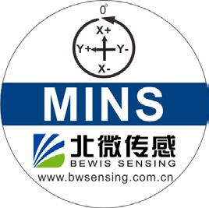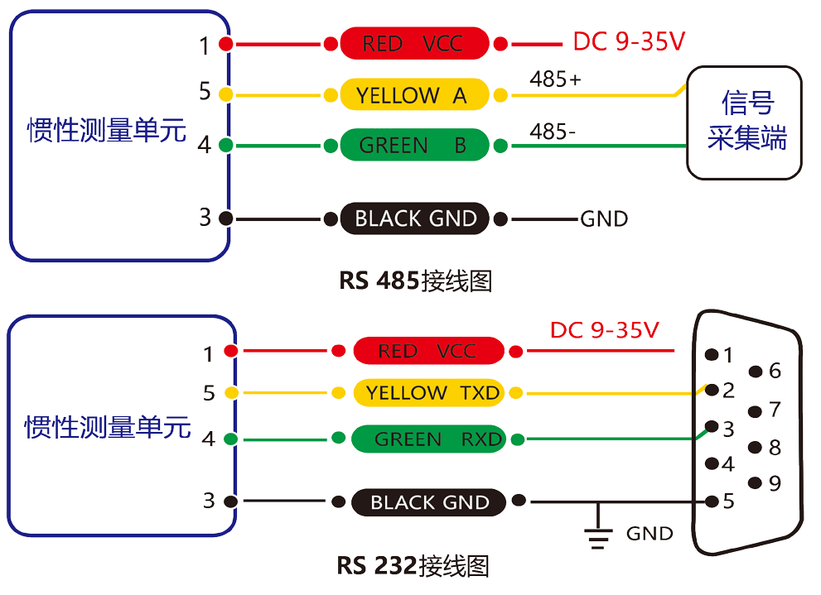

IMU

Axial definition

Three-axis attitude, gyroscope, acceleration data axis

All comply with the right-hand rule.

**RS232 Wiring Diagram**

**RS485 Wiring Diagram**

**MINS**

Signal acquisition terminal

**MINS**

**Testing software**

You can download the serial debugging assistant directly on the official website (technical service -> download area), or you can use the more convenient and intuitive host computer software. The BW-MINS100 supporting serial port debugging software can connect the inclination sensor on the computer to display the angle. The software debugging interface is shown in the figure below. Using the tilt angle to debug the host computer, you can easily display the current X and Y directions, and you can also modify and set other parameters.

Steps to use the software:

① Connect the inclinometer's serial hardware correctly and connect the power supply.

② Select the correct device model (select azimuth series).

③ Select the computer serial port and baud rate and click Connect Serial Port.

④ Click Start and the current tilt angle of the inclinometer in X and Y directions will be displayed on the screen.

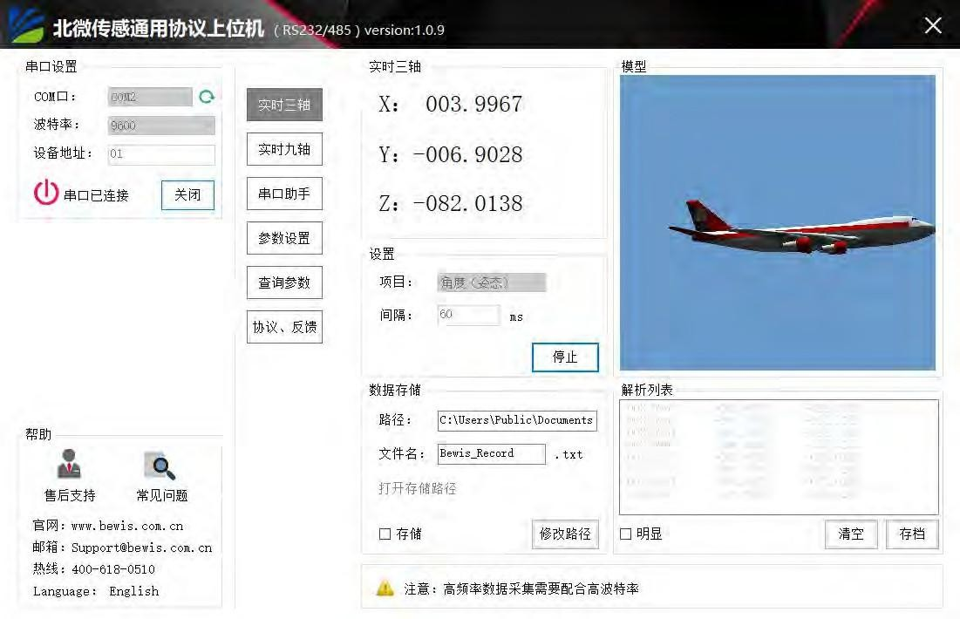

**Order information**

|  |  |  |  |  |
| --- | --- | --- | --- | --- |
| **Model** |  | **Communication mode** |  | **Package situation** |
| BW-MINS300-485 |  | RS485 |  | IP67 package/Metal interface |
| BW-MINS300-232 |  | RS232 |  | IP67 package/Metal interface |
| BW-MINS300-TTL |  | TTL |  | IP67 package/Metal interface |

**Executive standard**

● National Standard for Static Calibration of Biaxial Inclination Sensors (Draft)

●GB/T 191 SJ 20873-2003 General Specification for Tiltmeters and Leveling Devices

# BW-MINS300 Series

**Cost-effective micro inertial guidance system**

**Wuxi Bewis Sensing Technology LLC**

#### Add：Building 30, NO. 58, Xiuxi Road, Binhu District, Wuxi Jiangsu China

Tel：+86 18921292620

Mail[：sales@bwsensing.com](mailto:sales@bwsensing.com) Web：[www.bwsensing.com.](http://www.bwsensing.com/)